**Jira Tool**

* Jira Is a project management tool used to track project progress.
* First, we create account using our credintals.
* 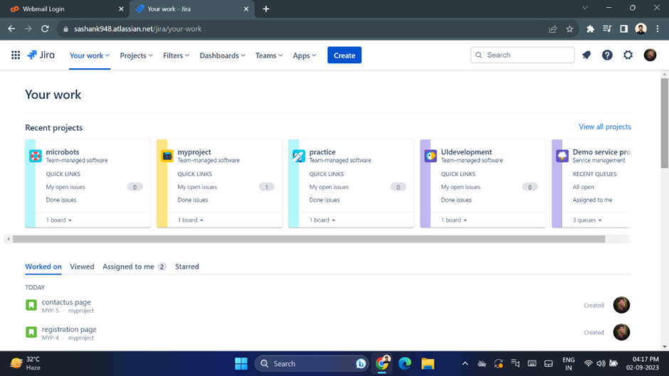Then we create project on which we work on.
* In projects, select create project.

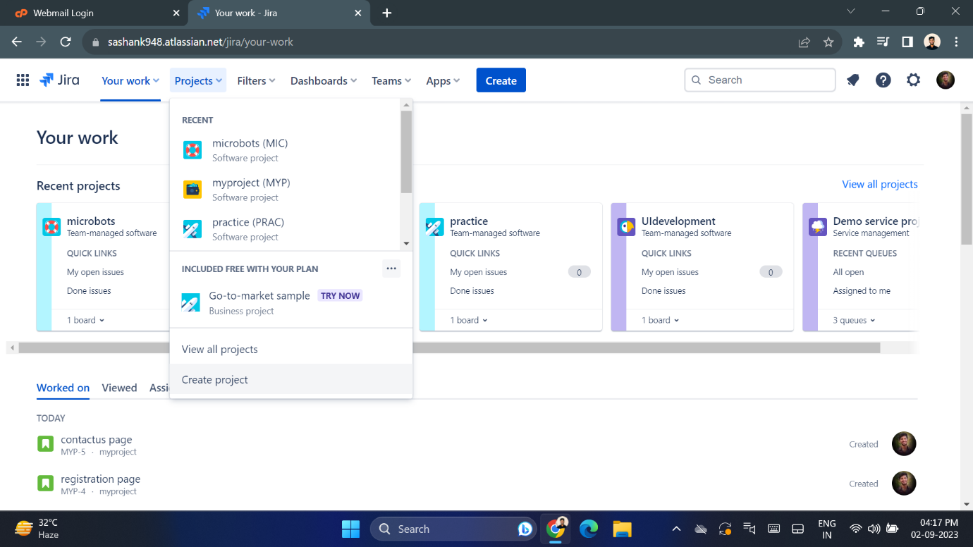

* Then it will redirect to project template page, there select scrum.

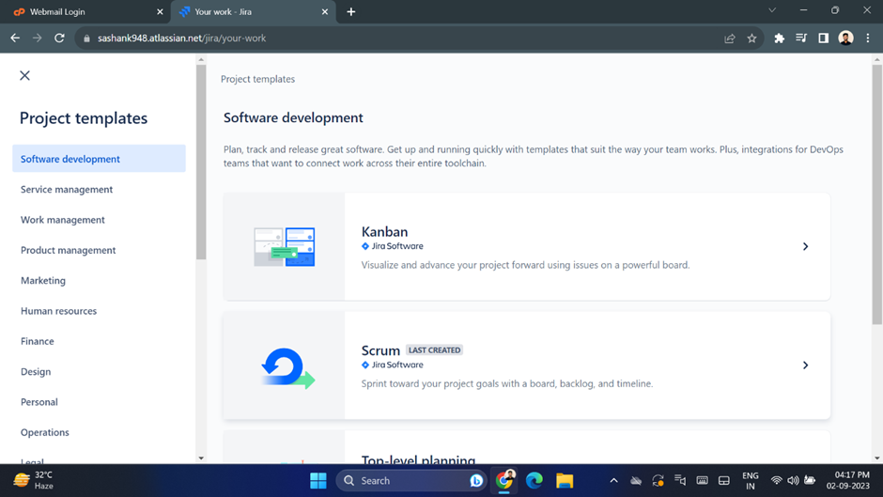

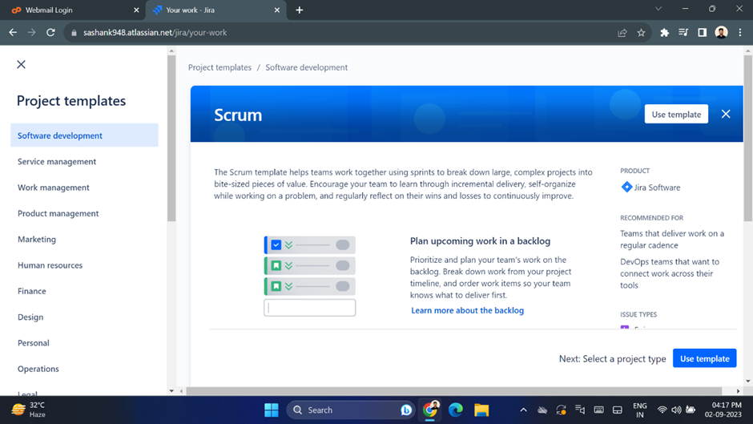

* Choose team managed project type.

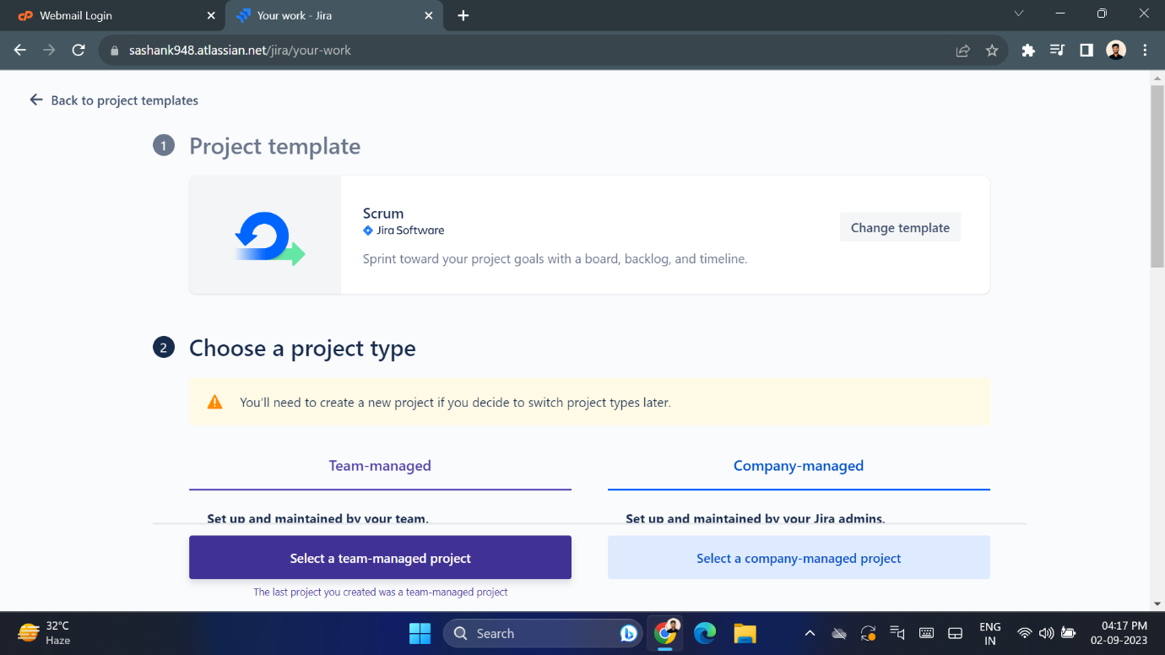

* Now name the project.

